Class Activity - What's Going On?

Objectives
Identify the processes running on a computer, the protocol they are using, and their local and remote port addresses.
Part 1: Download and install the TCPView software.
Part 2: Answer the following questions.
Part 3: Use a browser and observe the TCPView window.

Background / Scenario
For a hacker to establish a connection to a remote computer, a port must be listening on that device. This may be due to infection by malware, or a vulnerability in a legitimate piece of software. A utility, such as TCPView, can be used to detect open ports, monitor them in real-time, and close active ports and processes using them.

Required Resources
- PC with Internet access
- TCPView software

Instructions

Download and install the TCPView software.
    - Click the link below to reach the download page for TCPView.
http://technet.microsoft.com/en-us/sysinternals/tcpview.aspx
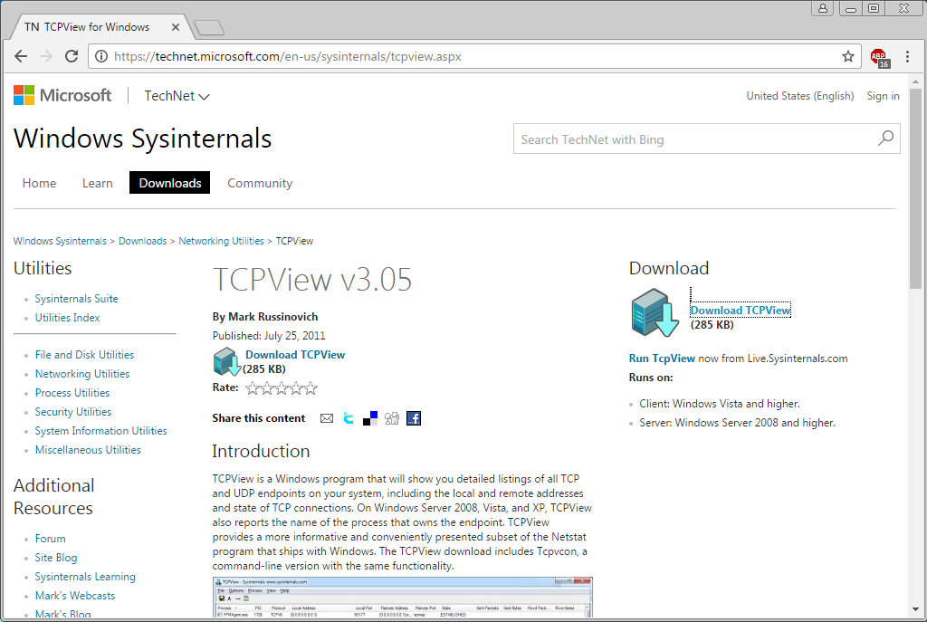
    - Create a folder on the desktop named TCPView.
    - Extract the contents of the zip to this new folder.
    - Start the Tcpview Application.
    - Finally, Agree to the software license terms.
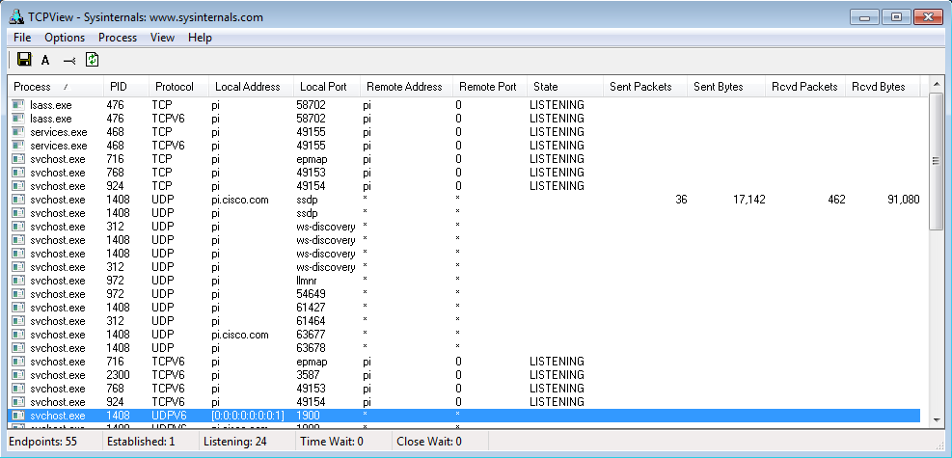

Answer the following questions.

Questions:
    - How many Endpoints are listed?
Type your answers here.
    - How many are Listening?
Type your answers here.
    - How many Endpoints are Established?
Type your answers here.

Use a browser and observe the TCPView window.
    - Open the Options menu and click “Always on Top”.
Note: Use the Help section of the program to help you answer the following questions.
    - Open any browser.

Question:
What happens in the TCPView window?
Type your answers here.
    - Browse to cisco.com.

Question:
What happens in the TCPView window?
Type your answers here.
    - Close the browser.

Questions:
What happens in the TCPView window?
Type your answers here.
What do you think the colors mean?
Type your answers here.
Note: To close a process directly, right-click the process and choose End Process. Using this method can cause a program or the operating system to become unstable. Only end processes that you know are safe to end. This method can be used to stop malware from communicating.

Lab Answers

Part 1
- Step 1
  - Screenshot showing that TCPView is installed and running
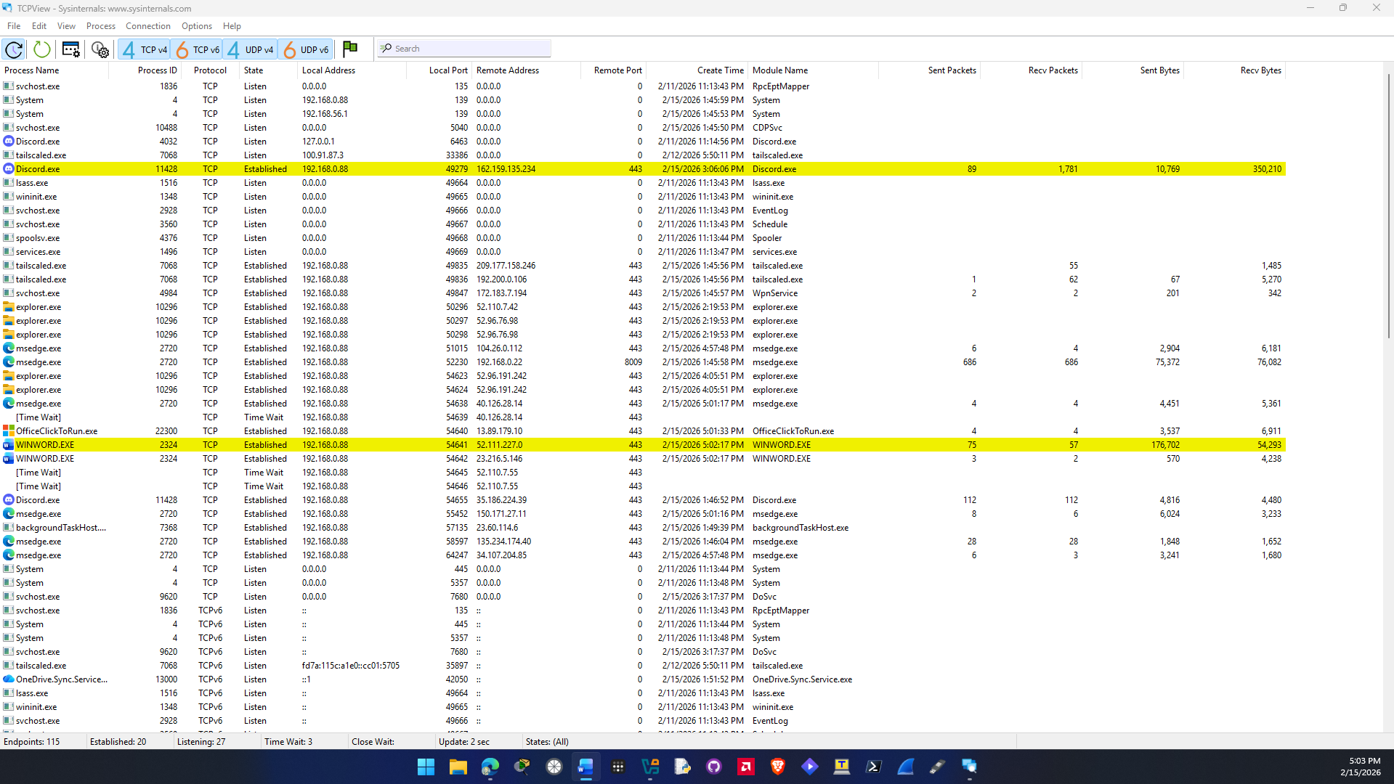

Part 2
- Step 1
  - Screenshot showing number of Endpoints, Listening, and Established
Question a. 113 endpoints on my computer.
Question b. 27 Listening on my computer.
Question c. 18 Established endpoints on my computer.

Part 3
b. I opened brave browser and multiple processes opened and brave.exe showed up green and flashed yellow occasionally.

c. When I entered cisco.com on brave browser more brave.exe prcesses opened and appeared green on the TCPView screen.

I think the colors mean something. Green indicates a process is starting. Yellow probably indicates a process is waiting for an action and red probably means the process is closing. If there is no color then the process is running.

